# **[Demo 5: How to use Arduino ESP32 to display information on SPI LED matrix](http://www.iotsharing.com/2017/05/how-to-use-arduino-esp32-to-display-spi-led-matrix.html)**

**1. Introduction**  
This demonstration show you **how to connect a LED Matrix module to Arduino ESP32** via MAX7219 module to display information from ESP32. There are 2 ways to connect ESP32 to LED Matrix module:

Connect directly. By using this way, ESP32 will waste many GPIO pins (at lest 8x8 for 8x8 Led matrix).

Connect via MAX7219 module. By using this way, ESP32 will only use 3 GPIO pins which act as SPI MOSI, CLK and CS pins. MAX7219 will be responsible for converting SPI data to LED Matrix data and control signals.

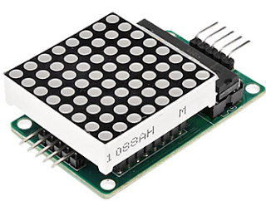

**Figure: Led matrix**

**2. Hardware**

Connect the pins of ESP32 to the pins of LED matrix:

[ESP32 GPIO14 - LED CLK]聽

[ESP32 GPIO12 - LED DIN (MOSI)]

[ESP32 GPIO15 - LED CS]  
[ESP32 GND - LED GND]

[LED VCC - 5V]

or follow picture below:

[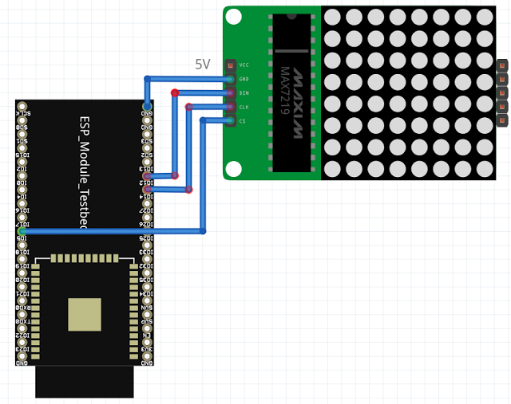](https://3.bp.blogspot.com/-AZl07j04pwQ/WRnLQzN40yI/AAAAAAAAD0U/rqYWf9uVXAAutRD_DsFDQ6tnddOcDrOKwCEw/s1600/ledmatrix2.png)

**Figure: ESP32 connect to LED matrix module**

**3. Software**

We will use the library **MAX7219LedMatrix** that is made for Arduino but I modified a little to compatible with ESP32. You can download the library here:

[https://github.com/nhatuan84/esp32-led-matrix](https://github.com/nhatuan84/esp32_ledmatrix)

**After downloading, unzip and copy the unzipped folder under folder:**

**[C:/Users/[YOUR_USER_NAME]/Documents/Arduino/libraries](https://www.blogger.com/null)**

**The library supplied some functions:**

**init()**: to initialize library

**setText()**: set the text to print on LED Matrix

**scrollTextLeft()**: scroll text to left effect

**clear()**: clear the display

**drawText()**: start drawing text to buffer

**commit()**: commit the text from buffer to LED Matrix

In order to use these function you need to create an instance of **LedMatrix** with constructor:**LedMatrix ledMatrix=LedMatrix(NUMBER_OF_DEVICES, CLK_PIN, MISO_PIN, MOSI_PIN, CS_PIN)**

**Note: NUMBER_OF_DEVICES number of cascading LED Matrix in a serial mode**

**[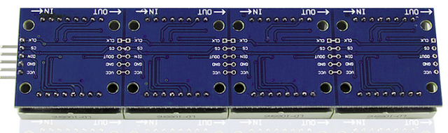](https://3.bp.blogspot.com/-bOnn5siyq-I/WRnLT873H7I/AAAAAAAAD0Y/BF5y3owFDOQDibwRuXV6cOfZIwqj6SiTwCEw/s1600/ledmatrix3.png)**

**Figure: 4 LED Matrix in a serial mode**

Finally, you create an Arduino project and save it as **esp32ledmatrix** with code:

|  |
| --- |
| #include <SPI.h>  #include "LedMatrix.h"  #define NUMBER_OF_DEVICES 3 //number of led matrix connect in series  #define CS_PIN 15  #define CLK_PIN 14  #define MISO_PIN 2 //we do not use this pin just fill to match constructor  #define MOSI_PIN 12  LedMatrix ledMatrix = LedMatrix(NUMBER_OF_DEVICES, CLK_PIN, MISO_PIN, MOSI_PIN, CS_PIN);    void setup() {  ledMatrix.init();  ledMatrix.setText("EasyIoT");  }  void loop() {  ledMatrix.clear();  ledMatrix.scrollTextLeft();  ledMatrix.drawText();  ledMatrix.commit();  delay(50);  } |

1. **Result**

